Testing Analysis – Electronics Store
Course: Software Testing
Project: Electronics Store
Student: Jurgen Hila

1. Introduction
This document presents the testing analysis for the Electronics Store project.
The goal of this testing activity is to apply Boundary Value Testing, Equivalence Class Testing, and Code Coverage techniques on selected methods from the Model layer.
The selected methods were chosen because they contain clear input constraints, branching logic, and exception handling, making them suitable for systematic testing.

2. Selected Methods
The following methods were selected for testing:
- Bill.addItem(Item item, int quantity)
- Bill.removeItem(Item item)
- UniqueIDGenerator.getUniqueId()
These methods are part of the Model layer and represent core business logic of the application.

3. Boundary Value Testing

Method: Bill.addItem(Item item, int quantity)
Boundary Value Testing was applied to the quantity parameter in relation to the available item stock.
Assumption:
Item stock = 10 units

Test Cases
Test Case | Quantity | Expected Result | Actual Result | Status
BV1 | 9 | Item added successfully | Item added | Pass
BV2 | 10 | Item added, stock becomes 0 | Item added | Pass
BV3 | 11 | Exception thrown | Exception thrown | Pass
Observation:
The method correctly enforces stock boundaries by throwing an InsufficientStockException when the requested quantity exceeds available stock.

4. Equivalence Class Testing

4.1 Equivalence Class Testing – Bill.addItem
The input values were divided into the following equivalence classes:
- Valid class: quantity ≤ available stock
- Invalid class: quantity > available stock

Representative Values
Class Type | Quantity | Expected Result | Status
Valid | 5 | Item added successfully | Pass
Valid (Boundary) | 10 | Item added successfully | Pass
Invalid | 11 | Exception thrown | Pass

4.2 Equivalence Class Testing – Bill.removeItem
Equivalence classes were defined based on whether the item exists in the bill.
- Valid class: item exists in the bill
- Invalid class: item does not exist in the bill

Test Cases
Scenario | Expected Result | Actual Result | Status
Item exists in bill | Item removed, stock restored | Correct behavior | Pass
Item not in bill | Exception thrown | IndexOutOfBoundsException | Pass
Observation:
The method does not handle the case where the item is missing gracefully, indicating a potential improvement opportunity.

5. Code Coverage
Code coverage analysis was performed using IntelliJ IDEA – Run with Coverage.

Coverage Results
- Model package:
  - 61% class coverage
  - 38% line coverage
- UniqueIDGenerator:
  - 100% method coverage
- Bill:
  - Covered both normal and exceptional execution paths:
    - Successful item addition
    - Boundary condition handling
    - Exception handling
    - Item removal (valid and invalid cases)

Coverage Screenshot
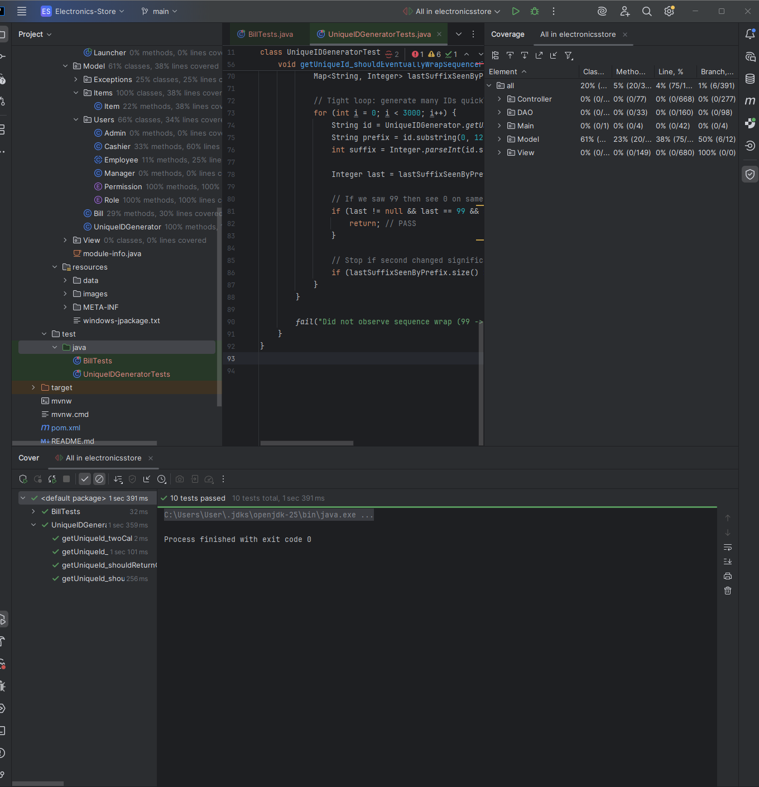

6. Conclusion
All selected testing techniques were successfully applied to the chosen methods.
The tests validated correct behavior at boundary conditions, across equivalence classes, and ensured that important execution paths were covered.
The testing process also revealed minor design issues, such as missing validation in the removeItem method, demonstrating the value of systematic software testing.

